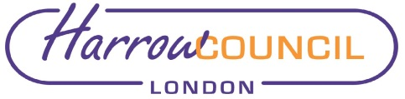

REPORT FOR: | HEALTH AND WELLBEING BOARD
Date of Meeting: | 17 March 2020
Subject: | CAMHS Local Transformation Plan (LTP) Refresh
Responsible Officer: | Javina Sehgal – Managing Director Harrow CCG
Public: | Yes
Wards affected: | All Wards
Enclosures: | - North West London (NWL) CAMHS Transformation Plan  - Annex E – Harrow CAMHS Transformation Plan Refresh

Section 1 – Summary and Recommendations

This summary report for the Health and WellBeing Board and the two attached papers set out progress and plans for mental health services for Harrow young people in line with the expectations of the government’s Future in Mind (2015) initiative.

Recommendations:

The Board is requested to:

1. Note the progress made in developing mental health services for young people across Harrow.

2. Formally sign off the NWL CAMHS Transformation Plan and the Harrow CAMHS Transformation Annex Refresh for publication on the NWL CCG, Harrow CCG and Harrow Local Authority websites

Section 2 – Report

Background

The report updates the Board on the progress of the CAMHS Transformation Programme, which has been running from 2015-2019, and demonstrates where additional investment from NHS England has improved outcomes for Harrow’s children and young people. Following the publication of Future in Mind in 2015 and the funding associated with it, from August 2015, all 8 CCGs across NW London have had a joint CAMHS Local Transformation Plan which outlines how investment will improve CAMHS. This is coordinated by the LikeMinded Team in North West London. This has ensured a lean approach to implementation and enables consistent standards to be driven up across the 8 boroughs; however the plan also reflects local differences and priorities in individual borough annexes. CCGs in collaboration with Local Authorities are expected to produce an annual CAMHS Transformation Plan that summarises progress so far and sets out plans for the future. These plans are submitted to NHS England each autumn, and assured against key lines of enquiry. This plan has been refreshed every year since 2015, and is now in its final iteration.

Current situation

The LTP is an assurance document that sets out how NHS Harrow Clinical Commissioning Group (CCG) works with children, young people, and other local stakeholders and partners to deliver the national, regional and local vision to achieve the best mental health and well-being outcomes. This refresh of the local transformation plan (2019) provides an update on progress made over the past year, towards delivering the priorities in the national strategies, and local transformation for children and young people’s emotional well-being and mental health. Harrows annex was submitted to NHSE/I and Harrow received a high level of assurance with 80% KLOEs rated as ‘green’.

NW London Shared Priorities
During 2018/19 significant progress has been made towards achieving Five Year Forward View targets for CYP MH, and in delivering the third year priorities.
We are continuing to explore opportunities to enhance and improve our services whilst also delivering the priorities outlined in the original plan. Work is continuing to build a whole system approach to commissioning and delivery of services, improving timely access to evidence-based treatments and improve timeliness of interventions. For those CYP who are most vulnerable, the refreshed LTP provides opportunities to develop and implement support models that ensure continuity of care, improved experience and provision of care in the community.

Based on our understanding of need, performance of services and progress made against key national and local indicators, and the vision of the NHS Long Term Plan, we are continuing to deliver against our previously defined priority areas as well as concentrating on two new areas: mental health support teams in schools and the development of a comprehensive 0-25s offer.

Our NW London priorities for 2019 are:

Harrow Annex

Harrow Council and Harrow CCG commissioners have collaborated to produce the Harrow CAMHS Transformation Refresh report (Annexe E).
In Harrow there is a strong, close and effective working relationship between the Council and the CCG with both agencies investing in mental health services for young people.

Harrow CCG invests £2,080,307 with Central and North West London Mental Health Trust (CNWL) who provide the Harrow CAMHS service operating from the Ash Tree Clinic in South Harrow.

Harrow Council jointly commissions the Banardo’s Harrow Horizons service with the CCG, contributing £270,000 annually with council and CCG staff managing the contract together. Harrow schools are also able to “buy in” an enhanced service from Harrow Horizons to meet the needs of local young people.

The CCG also invests £500,693 from CAMHS Transformation funds, supporting the jointly commissioned Barnardo’s Harrow Horizons early intervention service as well as the CAMHS Crisis services, NWL Eating Disorder Service, Kooth and Youth Justice CAMHS worker.

Full details about how the CAMHS Transformation funding is allocated in Harrow can be found in the attached Harrow CAMHS Transformation Plan Refresh Annex E.

For the 2019 submission NHS England has varied their assurance process and both the attached NWL CAMHS Transformation Plan 2015-20 and the Harrow Plan (Annex E) have been submitted to NHS England in draft form, prior to sign off by the Harrow HWBB. NHSE signalled that the 2019 assurance process would be a light touch meaning that the transformation plan need not be fully updated but focus on addressing the new areas introduced in the key lines of enquiry (KLOES). The KLOES are questions that are required to be answered by the transformation plan that cover: Transparency and Governance; Understanding local Need LTP Ambitions; Workforce; Health & Justice; Eating Disorders; Data – Access and Outcomes; Urgent and Emergency (Crisis) Early Intervention into Psychosis; CYP MH services working with educational settings.
NHS England have provided feedback on the assurance process and Harrow met 80% assurance.

The 2019 refreshed plan builds on the progress made in previous years; it outlines ongoing plans to affect whole system change, address gaps in provision that remain and any emerging areas of need

In that time, the following key achievements have been made:

- Coproduced redesign and procurement of the early intervention and prevention wellbeing service Harrow Horizons
- Increased numbers of CYP accessing the appropriate evidence based treatment to aid their recovery;
- Reduction in waiting times for treatment, providing more timely interventions to help minimise escalation of needs;
- Following engagement from young people we have extended our digital offer Kooth to all Harrow secondary schools and colleges and for CYP up to 25 years old.
- Engagement with stakeholder, CYP and their families, including patient stories at the CCG Governing Body and coproduction of Autism pathway.
- CCG CYP Engagement Youth Representatives who have been involved in updating the CCG website to include a section on CYP and mental health service.
- The SEND inspection stated “The CAMHS learning disability team offers a wide range of services to parents, carers and families of those with a learning disability. Specialist sessions for siblings provide them with a safe place to discuss emotions, needs and lived experiences. This practice plays a vital part in preventing family breakdowns”.

This transformation plan acknowledges that there remain a number of key challenges, especially in terms of current and future workforce capacity and skill mix, but also in terms of financial pressures, data capture and utilisation. These challenges remain the potential destabilisers to delivering the ambitions and aspirations of the NHS Long Term Plan but we are working closely with our partners to mitigate these risks wherever possible.

Next Steps:
- Providing better crisis care in the community including the development of a crisis line for under 18s.
- Development and implementation of a comprehensive model of care to support seamless transitions for CYP moving to adult mental health services and development of 0-25 MH services.
- Work towards an integrated care programme and linking with our local Primary Care Network PCNs and development of engagement.

The Local Area review for SEND in July 2019 identified that Harrow has effective arrangements with the child and adolescent mental health service (CAMHS) ensure that young people who have social, emotional and mental health (SEMH) needs are fast tracked. This means that their emerging needs are responded to as quickly as possible.

In December 2017 the Department of Education published its Green Paper ‘Transforming children and young people’s mental health provision There are three key elements to the Green Paper’s ambitions:
- To incentivise and support all schools to identify and train a Designated Senior Lead for Mental Health with a new offer of training to help leads and staff deliver whole school approaches to promoting better mental health.
- To fund new Mental Health Support Teams, supervised by NHS children and young people’s mental health staff, to provide a specific extra capacity for early intervention and ongoing help within a school and college setting.
- As the new Support Teams are rolled out, NHS England will trial a four week waiting time pilot (these are currently in operation in a number of areas throughout the UK) for access to specialist NHS children and young people’s mental health services. This builds on the expansion of specialist NHS services already underway. In addition, the Green Paper consultations covered several other issues, including how schools can provide enough information on mental health support to parents and carers and how to take forward work to enable schools and colleges to measure the impact of what they do to support children and young people’s mental wellbeing.

On two occasions to date, NHS England have sought expressions from CCG’s, working collaboratively with partners, to create new, local Mental Health Support Teams (MHST) as part of a Trailblazer programme. The aim of the MHST’s are to:
Deliver evidence-based interventions in or close to schools and colleges for those with mild to moderate mental health issues
Help children and young people with more severe needs to access the right support
Work with and within schools and colleges, providing a link to specialist NHS services
Build on and increase support already in place, not replace it.

Unfortunately Harrow’s bids to be a Trailblazer site were unsuccessful on both occasions. However, the CCG and partners, understanding the importance of developing mental health support in schools, we will ensure that we continue to submit EOI for this programme.

Why a change is needed

Across NWL our ambition has been to ensure, by 2021, that every CYP in NW London can access appropriate needs based, person centred mental health support that significantly improves outcomes. We have set up our CYP mental health programme to drive transformation and help make this vision a reality

The Ambition

The single greatest cause of concern amongst our young people and the professionals they interact with is about the barriers between different parts of the system. This tiered care system has at times restricted and limited the ability of a child or young person being seen by the most appropriate person or service; at the most appropriate time or suitable place.

We have set our ambition to move away from tiered services and eliminate boundaries and challenges of the old system to a new system in which CYP are supported in their communities with services that are accessible and in accordance with the level of need.

The commissioners, clinicians and other stakeholders engaged and involved in our transformation programme have agreed to adopt THRIVE as a framework that supports our ambition to eliminate the boundaries between services and pathways and the culture shift needed across the system. The framework provides a dynamic and innovative approach, moving towards a goal-focussed model that is not defined by tiers, and places a greater emphasis on prevention and early intervention.

The THRIVE framework is a way of conceptualising need amongst a community of CYP and their families. Need is measured under the five categories.
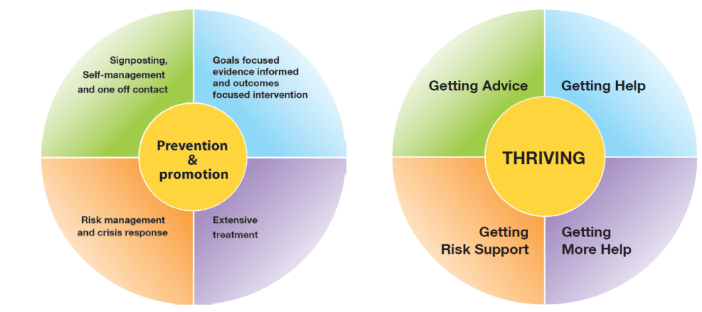
THRIVE conceptual Framework

- Thriving: Focus on community based initiatives concentrating on prevention and promotion of emotional wellbeing.
- Getting Advice: Building resilience to support communities (school and family) to prevent, support and intervene in mental health issues.
- Getting Help: Focuses on health based interventions with clear treatment goals and set criteria to assess whether those aims had been achieved.
- Getting More Help: Emphasis on intensive and extensive longer-term health based treatment.
- Risk Support: Often resource intensive and requiring considerable input, this group focuses on those CYP for whom traditional health based care does not currently meet their needs.
Through adopting this framework, the outcomes we are seeking to achieve are:

- Reducing inequalities and improving health outcomes for CYP (including equality/social cohesion, financial inclusion, attainment levels);
- Building a sustainable future (environment and sustainability);
- Improving the quality of care and experience; and
- Improving value and efficiency.

It is a requirement of NHS England that the refresh is discussed and signed off by local Health and Wellbeing Boards and that this is recorded on the plan to ensure that the Local area has signed up to the proposals and is in agreement to the ambition and direction of travel for the Emotional Mental Health and Wellbeing and specialist CAMH services. Therefore it is essential that the refresh is presented and discussed at the Harrow Health and Wellbeing board.

Financial Implications/Comments
There are no direct financial implications identified within this report.

The majority of funding for young people’s mental health services in Harrow comes from Harrow CCG. The contract and budget for Harrow CAMHS which is provided by Central and North West London Mental Health Trust (CNWL) is confirmed by the CCG’s Finance Director on an annual basis.

Expenditure against both the CNWL contract and CAMHS Transformation funds is within budget and as a result there are no financial implications resulting from these CAMHS transformation reports.

As part of the CAMHS Transformation funding our online digital platform Kooth and Barnardo’s Harrow Horizons provide early intervention services. Harrow Horizons is joint funded with Harrow Council on a 50-50 split. As both the council and the CCG have allocated budget for this activity there are no adverse financial implications.

From 2019/20 onwards, baseline funding for CCGs is increasing in line with the commitments set out in the NHS Long Term Plan, and transformation funding associated with the delivery of specific initiatives has been secured.

Legal Implications/Comments
Legal note there are no specific implications and risks identified within this Report.

Risk Management Implications

There are no risks identified in this report

Equalities implications / Public Sector Equality Duty

Was an Equality Impact Assessment carried out? No
No change in service within the report

Council Priorities

Please identify how the decision sought delivers these priorities.

- Building a Better Harrow
- Create a thriving modern, inclusive and vibrant Harrow that people can be proud to call home

- Supporting Those Most in Need
- Empower residents to maintain their well-being and independence
- Children and young people are given the opportunities to have the best start in life and families can thrive

- Protecting Vital Public Services
- Healthcare services meet the needs of Harrow residents
- A strong and resourceful community sector, able to come together to deal with local issues
- Harrow continues to be one of the safest boroughs in London

- Delivering a Strong local Economy for All
- A strong, vibrant local economy where local businesses and thrive and grow
- Modernising Harrow Council
- Deliver excellent value for money services
- Improving access to digital services

Section 3 – Statutory Officer Clearance
(Council and Joint Reports)

Not required

Section 4 - Contact Details and Background Papers

- Contact: Report Anita Harris, Head of Children’s Commissioning, Harrow Clinical Commissioning Group 020 8966 1048
- Background Papers: List only public documents (ie not Private and Confidential/Part II documents) relied on to a material extent in preparing the report (eg previous reports). Where possible also include a web link to the documents.
- Harrow CAMHS Transformation Refresh 2018 Report to NHS England 10th January 2019 Harrow Health and Wellbeing Board
https://www2.harrow.gov.uk/documents/s153994/CAMHS%20Transformation%20Plan%20Refresh%20Jan%202019.pdf

Anna Freud National Centre for Children and Families THRIVE Framework

